


Temple Hill Primary Academy - PE Update for Governors – Summer 2 2025

A brief overview of what has been achieved so far:
- Purchased equipment to support teaching and learning and to support the OPAL strategy.
- Attended DDFA events.
- Liaised with other schools to organise football matches in T6 to offer a more varied and broader offer for external competitions.
- RAs updated for the next academic year.
- Contacted KCC regarding bikeability for Y6 in Term 6 – Did not have enough pupils wanting to participate.
- Began process of inter-house competitions with OPAL lead.
- Attended inter-house sports events targeting SEN pupils
- Temple Hill won the Golden Games!
- Our children have attended more competitions and a wider variety of competitions in many years.
- Achieved silver on the school Games mark report,
- PE monitoring in T5 was very insightful in identifying strengths and areas for improvement within PE at Temple Hill. We now have a list of actions from this to improve teaching and learning and support our teachers.
- OPAL play and lunch times has been very successful seeing more children active in play has led to less first aid and less behaviour issues. We are looking forward to seeing the impact of this on our children’s gross motor skills within their PE lessons over the next few academic years.
- Created a club (multi-sports) targeting PP students that was free to attend. Giving pupils the opportunity to experience different sports.
- Sporting certificates to raise the profile of sport.
Next Steps:
- Embed and promote inter-house competitions across the school and integrate into house point system.
- Book more CPD for teachers to continue developing confidence when teaching PE.
- Consider the use of knowledge organisers within PE and how these would be used.
- Train play leaders to run sporting events/activities.
- Attempt to implement Voice 21 (Oracy) into PE lessons.
- Attempt to support teachers in creating their own PE lesson plans so they are specific for Temple Hill Primary academy demographic.
Current Spend:
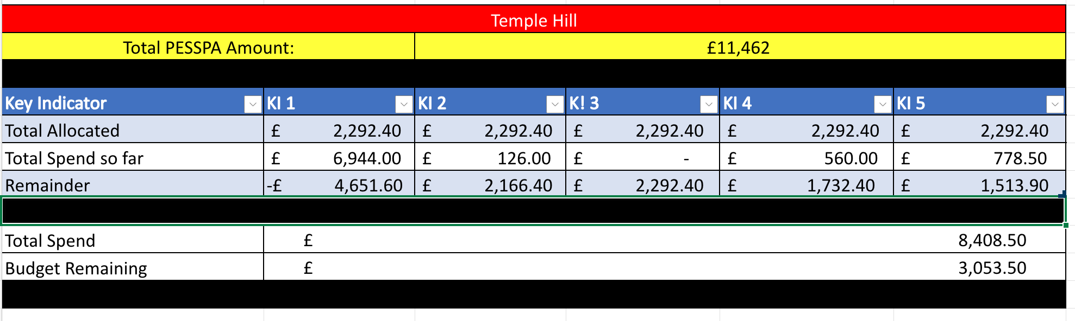

Breakdown of Spend So Far This Year:
PESSPA Spend - Breakdown
Date | Description | Spend | Spend Point
4/10/24 | 8’x6’ football flick urban match goals | £600 | 5
04/10/25 | Children play sand 49 x 20kg | 132.50 | 5
4/10/24 | Skipping ropes 7’ (set of 10) | £36.00 | 5
25/11/24 | JMF ALLSTARS, Multi-sports club targeting PP children | £1344 | 1
03/12/24 | JMF ALLSTARS, Multi-sports club targeting PP children | £1344 | 1
26/02/25 | JMF ALLSTARS, Multi-sports club targeting PP children | £1344 | 1
01/04/25 | JMF ALLSTARS, Multi-sports club targeting PP children | £1344 | 1
03/06/25 | JMF ALLSTARS, Multi-sports club targeting PP children | £1568 | 1
11/04/25 | ALLSTARS Sport and Mentor Academy | 560 | 4

Breakdown of Sports Clubs/Competition Attendance - (Cumulative Data from 2021 – 2023 as reference):
Summer 2 – Sports events
Event | Boys | Girls | SEN | PPM | Total
Golden games | 20 | 20 | 0 | 10 | 40
Jordan’s wood football friendly | 7 | 0 | 0 | 0 | 7
Total | 27 | 20 | 0 | 0 | 47
Percentage | 57.45% | 42.55% | 0% | 0%

Breakdown of Sports Clubs Offered: Paid/Unpaid:
Summer 2 - Sports Clubs (Contribution)
Sports Club | Boys | Girls | SEN | PPM | Total
Football Y3/4 | 13 | 1 | 1 | 4 | 14
Gymnastics | 4 | 26 | 5 | 8 | 30
Football Y5/6 | 11 | 0 | 0 | 4 | 11
Street Dance | 5 | 21 | 4 | 6 | 26
Football Y1/2 | 11 | 1 | 3 | 3 | 12
Total | 44 | 49 | 13 | 27 | 93
Percentage | 40.92% | 45.57% | 12.09% | 25.11%
Summer 2 - Sports Clubs (Free)
Free Sports Club | Boys | Girls | SEN | PPM | Total
Multi-sports Activity Club | 2 |  |  | 1 | 2
Total | 2 |  |  |  | 2
Percentage | 20%

